Period Analysis

Introduction
The purpose of period analysis is, as the term suggests, to identify candidate periods for a variable star from the available data. There are a number of ways to do this. Sometimes, one can simply inspect the light curve to find the time taken for the brightness change to go through one full cycle. For less obvious cases, an algorithm such as AoV, PDM, or Fourier analysis can be used to search for candidate periods.

VStar implements the Date Compensated Discrete Fourier Transform (DCDFT) algorithm (Ferraz-Mello 1981), yielding a power spectrum and a table of “top-hits” given a specified series, frequency (or period) range, and resolution. The “date compensated” part of the name indicates that gaps in the data, common for variable star observations, are compensated for by the algorithm.

From within the DCDFT result window, a phase plot can be created (see Phase Plots section for more information). In addition, one or more periods each with one or more harmonics can be selected to create a model. A model’s Fourier coefficients can be viewed along with relative amplitudes and phases.

Optionally, multiple periods found by DCDFT can subsequently be refined via the CLEANest (Foster 1995) algorithm.

When a model is created, it is also subtracted from observations in the series on which the DCDFT was performed to yield a second, “residuals,” series. DCDFT can then be applied to these residuals to look for further signals (periods), a process often called “pre-whitening.”

The following shows eta Aquilae data from AAVSO International Database (AID) in the JD range 2455695.8431 to 2456419.8604, a DCDFT “power spectrum”, and a phase plot resulting from a top-hit selection.
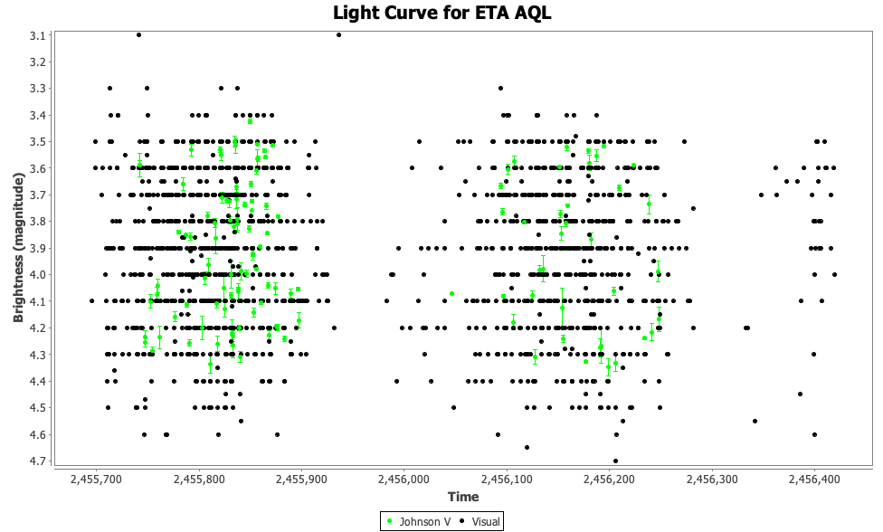

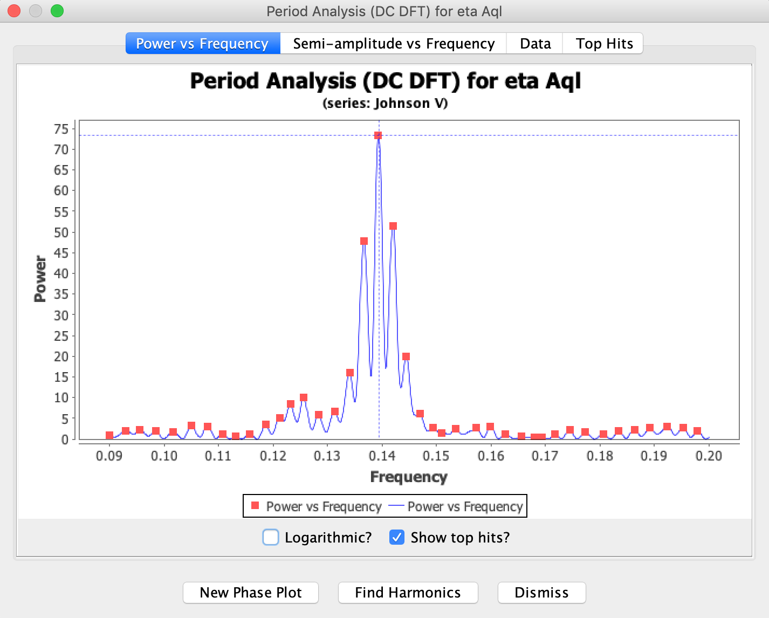
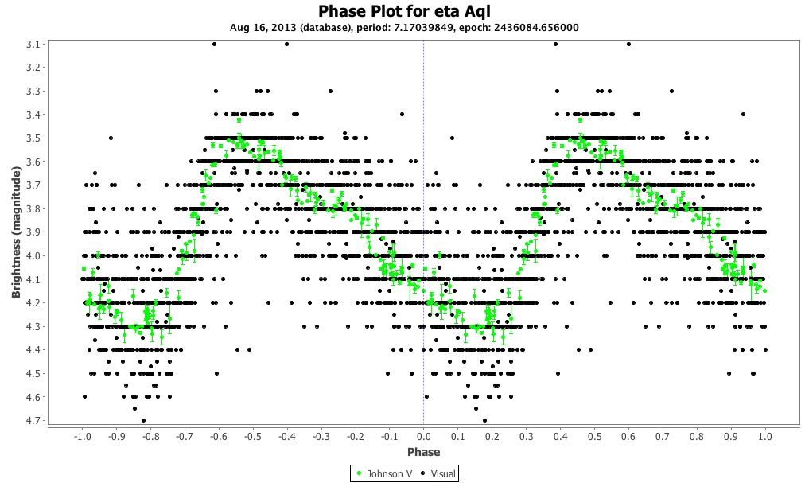

DCDFT in Detail
DCDFT menu items are available in the Analysis menu. As shown below, the options are DCDFT standard scan, DCDFT with frequency range, or with period range.

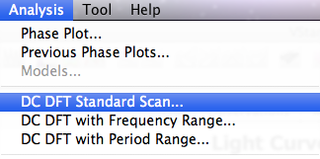

Looking at the eta Aql example above in more detail, selecting DCDFT Standard Scan... yields the series selection dialog, since period search is only applied to a single series:
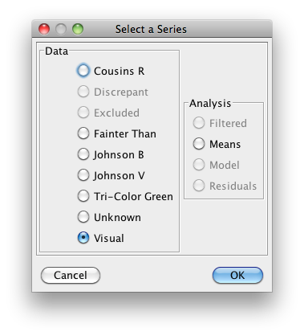
Here, the Visual series is selected. Clicking the OK button leads, after a short time, to the result dialog:
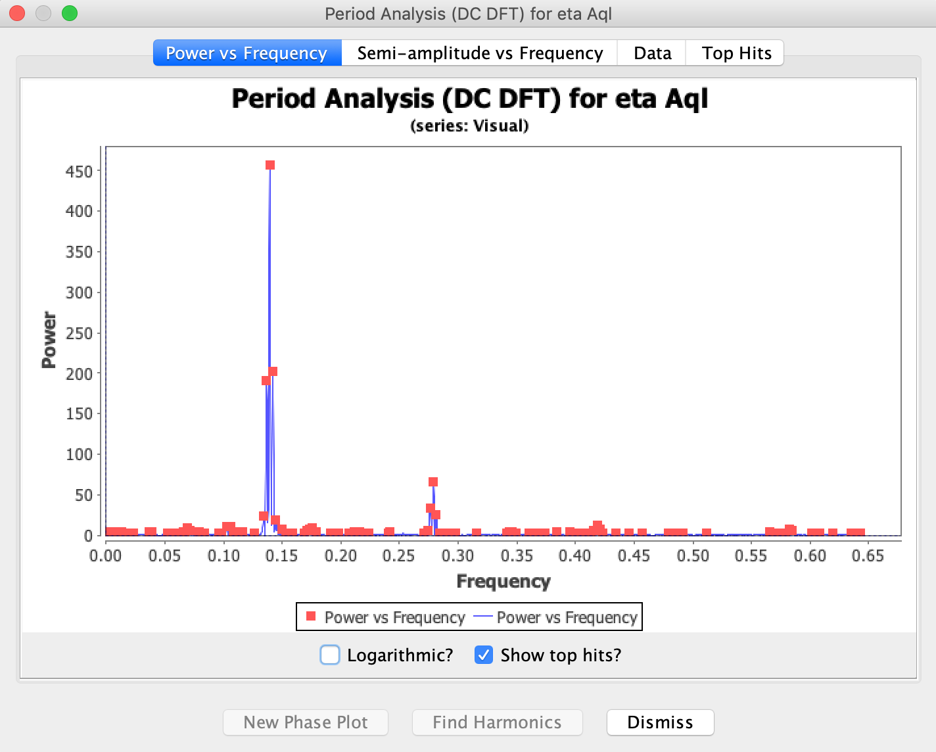

By default, the Power vs Frequency plot (sometimes called the “power spectrum”) is shown. Notice that Show top hits? is checked here, again, by default. The small brightly colored squares correspond to “top hits,” those frequencies/periods at the peaks of the plot (those with highest power value). These are the best candidates for the actual frequency (period).

As with all plots in VStar, zooming in to a DCDFT plot can be done by click-dragging a rectangular area of the plot or using the context menu (e.g. via right-click in Windows or ctrl-click on Mac OS X) Zoom In/Out items, as was done for the power spectrum shown in the Introduction section.

Before leaving this tab, notice the Logarithmic? checkbox. If selected, the power (or semi-amplitude in the case of the Semi-amplitude vs Frequency plot) axis will become a base-10 log scale. This can sometimes help to reveal frequencies of interest.

Selecting the Top Hits tab shows the top hits, referred to above, in tabular form.

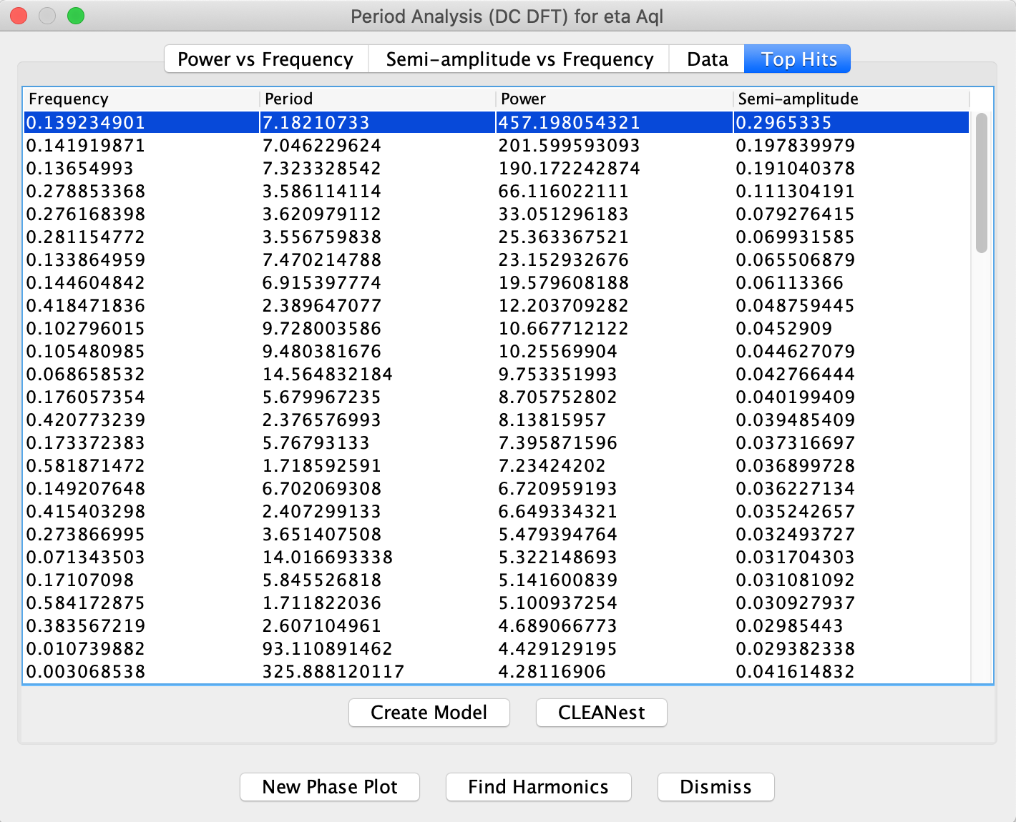
Clicking the New Phase Plot button with the shown top-hit selected will result in the phase seen earlier in this section.

Harmonics
The Find Harmonics button will show a list of harmonics of the main frequency (or period which is:
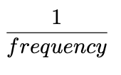
in the data. VStar adopts the convention (from Foster 2010) that the first harmonic is the fundamental frequency. This can be used as a decision support aid for model creation.

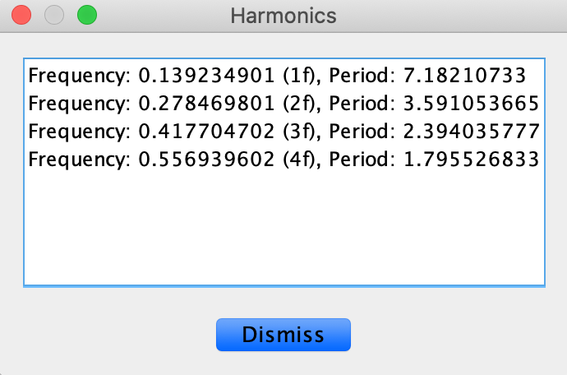

Creating Fourier Series Models
The Create Model button creates a Fourier series from the selected period and one or more harmonics selected from the following dialog. In this case, 4 harmonics are selected, which is to say, the fundamental and the next 3 harmonics.

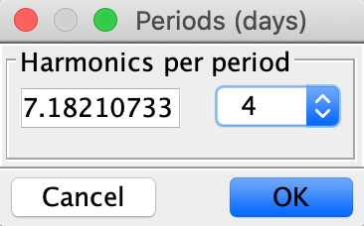
Clicking OK gives the following if phase plot mode is selected:

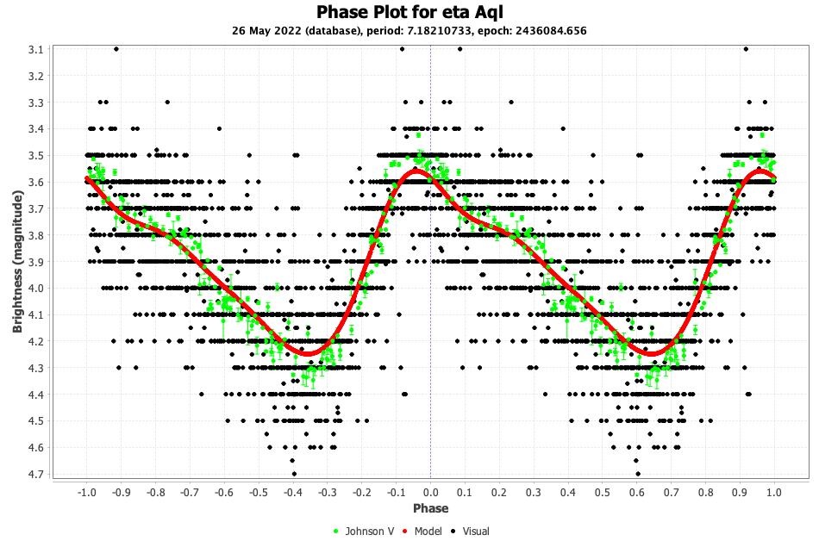

or the following if VStar is in raw data mode, by means of contrast immediately revealing the allure of the combination of period analysis, phase plots and models:

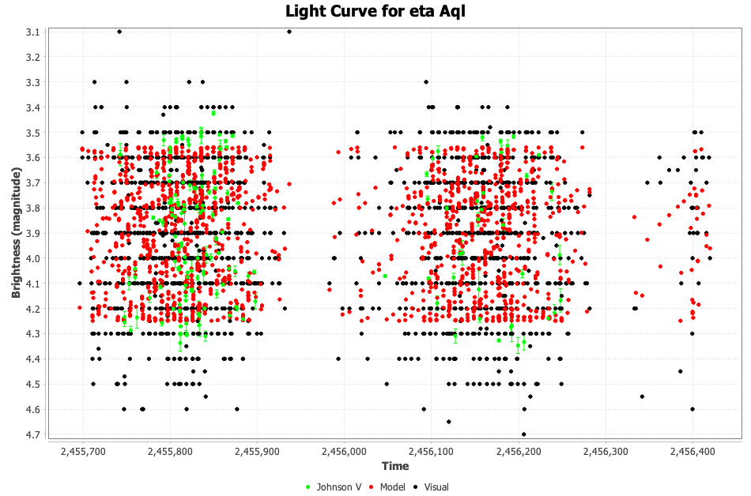

Previous models can be revisited via the models dialog, invoked by Analysis → Models...

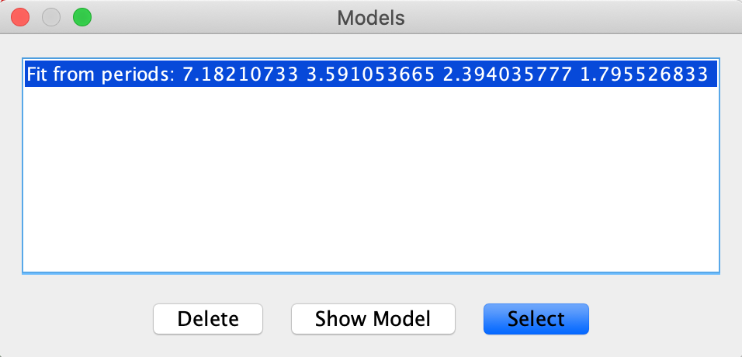

Models can be deleted or selected for plotting or inspection. Clicking the Show Model button opens a dialog that shows the selected model function in different forms.

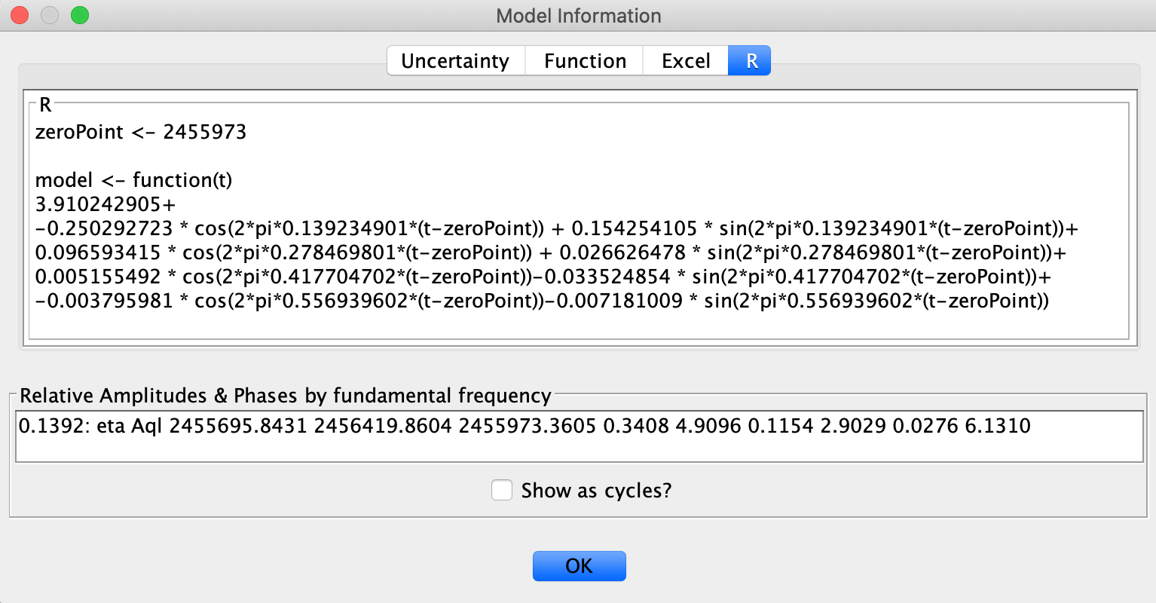

The model equations can be selected and copied with the mouse (via manual selection or select-all/copy keyboard shortcuts) and used as part of a script. For example, from the dialog above, the R Fourier series equation:

zeroPoint <- 2455973

model <- function(t)
3.910242905+
-0.250292723 * cos(2*pi*0.139234901*(t-zeroPoint)) + 0.154254105 * sin(2*pi*0.139234901*(t-zeroPoint))+
0.096593415 * cos(2*pi*0.278469801*(t-zeroPoint)) + 0.026626478 * sin(2*pi*0.278469801*(t-zeroPoint))+
0.005155492 * cos(2*pi*0.417704702*(t-zeroPoint))-0.033524854 * sin(2*pi*0.417704702*(t-zeroPoint))+
-0.003795981 * cos(2*pi*0.556939602*(t-zeroPoint))-0.007181009 * sin(2*pi*0.556939602*(t-zeroPoint))

can be used in conjunction with observations, model data and the script available at the following location to plot the model equation:

https://github.com/AAVSO/VStar/blob/master/script/plot_model.R

For a more comprehensive R based tool, see Maksym Pyatnytskyy's VStarModelPlot:

https://github.com/mpyat2/VStarModelPlot

The Excel formula should be copied and pasted into a text editor and linefeeds removed before pasting into Excel.

In the presence of a model with harmonics, the model information dialog will include a pane titled Relative Amplitudes & Phases by fundamental frequency. This is a standard way of describing the shape of a waveform, especially for pulsating stars with close-to-perfect periodicity. For more information about this, see Foster (2010).

Having created a model, looking at the residuals series can provide information about any remaining signal (e.g. via binned means; see also Current Mode ANOVA plug-in). The residuals series can, like any other series, have DCDFT applied to it to search for additional periods.

The Uncertainty tab gives measures of period error:

- Full-width Half-maximum (FWHM), an error defined as the absolute difference between the high and low frequency bounds for which the power (as shown on a DCDFT periodogram) is no less than half that of the selected fundamental (peak) frequency's power.
- Only if a single frequency with no harmonics is selected for model creation (since residuals are used in the calculations):
  - Standard error of the frequency
  - Standard error of the semi-amplitude

Equations for the standard errors are as follows:

Standard error of the frequency:

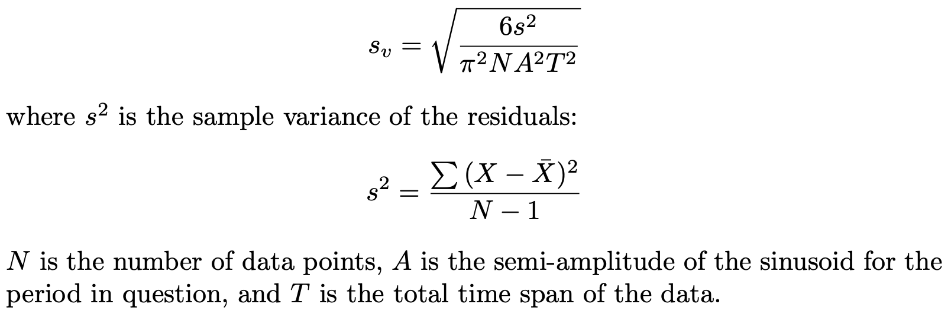
Standard error of the semi-amplitude (half the amplitude):
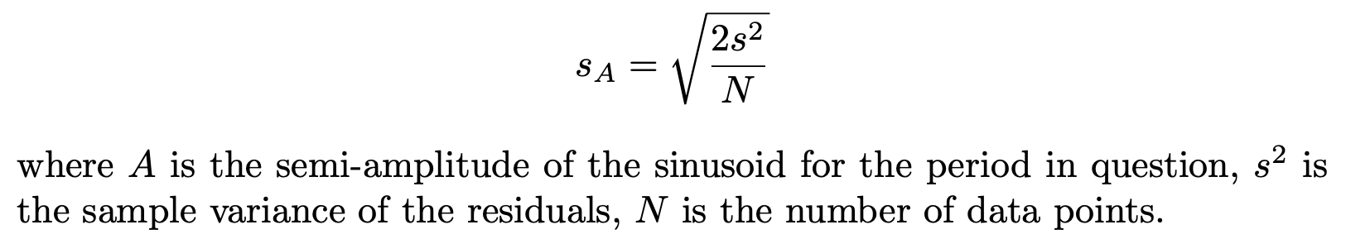

Foster (2010) says on page 154 that:

In most cases the possible range estimated by the theoretical formula is too liberal while the range estimated by FWHM is too conservative.

See Foster (2010), Section 7.10 for more information about period error.

Other DCDFT options: Period and Frequency Range
Up to this point, only the DCDFT standard scan has been mentioned. As can be seen from the Analysis menu, DCDFT with frequency range and period range are also available.

VStar’s DCDFT Java implementation is a direct translation of AAVSO’s TS program. The following is adapted from the documentation accompanying the Fortran TS implementation created by Matthew Templeton, which in turn was translated from a BASIC implementation by Grant Foster (see References section):
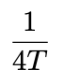
The simplest choice is DCDFT Standard Scan. The smallest frequency (longest period) tested by the standard scan is , where T is the total time span of the data. The standard scan will test frequencies from:
to:
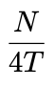
where N is the number of data, in steps of:

Because VStar utilizes a discrete form of the Fourier transform, the computation time will increase as the square of the number of data points. For 100,000 data points or more, consider averaging or filtering the data points prior to processing.

As it tests each frequency, VStar records the frequency, period, and power. Frequencies with the highest power levels are the most likely possibilities for the actual frequency of a periodic fluctuation in the data (if it has one; after all, not all data are periodic). VStar keeps a record of the top (highest power) 100 frequencies/periods (see Top Hits pane in the DCDFT result dialog).

To specify a range of frequencies or periods to test, choose option the DCDFT with Frequency Range or DCDFT with Period Range options. VStar requests the low frequency or period to test, the high frequency or period, and for the resolution. The resolution is the spacing between test frequencies or periods. For instance, to test a range of periods, from as low as 100 days to as high as 150 days, if a resolution of 1 is specified, VStar will test all periods from 100 to 150 in 1-day steps.

Note that non-zero values must be entered in the parameter dialog. The following figure shows an example of the parameter dialog for the scenario described above:
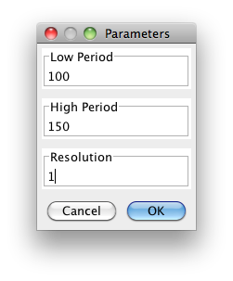
The DCDFT with Frequency Range option populates the dialog with an initial frequency range and resolution as described for Standard Scan above.

CLEANest
The TS documentation cited above goes on to make the following comment:

When you run a Fourier analysis of the data, it is possible that the "peak" signal or signals you detect may not be the precise frequency actually detected in the data set, because the sampled frequencies tested might be offset slightly from the true signals.

Like TS, VStar is capable of refining one or more periods simultaneously via the CLEANest (Foster 1995) algorithm.

Grant Foster’s 1995 CLEANest Fourier Spectrum paper (Foster 1995) gives a number of examples of applying the CLEANest algorithm to datasets, artificial and real. Two of these use AAVSO visual magnitude estimates: S Ori and AA Cas.

What follows will show VStar’s CLEANest implementation applied to AA Cas. Foster (1995) uses an AA Cas dataset in the JD range 2447500 to 2449500. Here is that dataset loaded from the AAVSO International Database (AID):

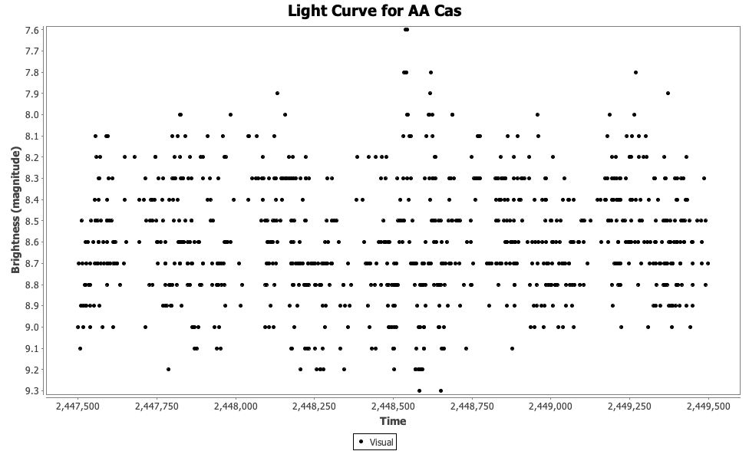

A DCDFT with frequency range can be initiated from VStar’s Analysis menu, selecting the Visual band and specifying minimum and maximum frequencies, the range over which to scan (0.0001 to 0.02), and frequency resolution (0.000001) over the range.
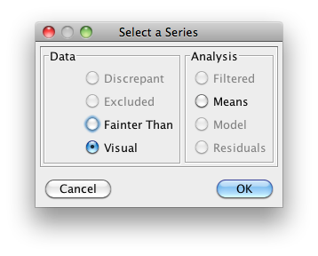 | 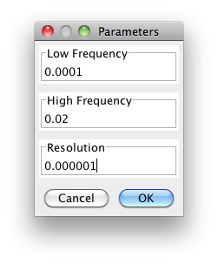
This results in the following power spectrum (in the Power vs Frequency pane) with the orange squares showing peaks or “top hits”.

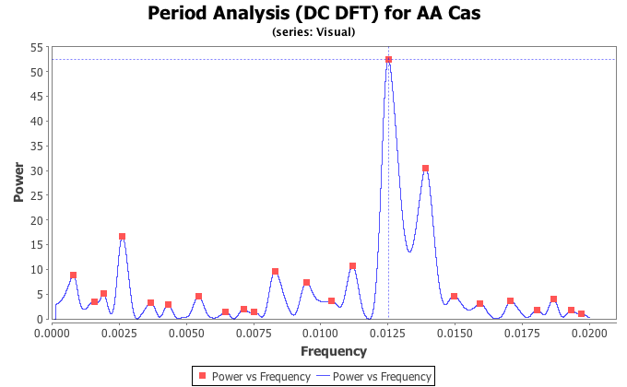

These top hits are shown in the next diagram in tabular form.

Notice that seven top hits are shown as being selected using combinations of shift-click and control-click (Windows) or command-click (Mac). The initial input values to CLEANest are not stated in Foster (1995; section 5, page 1900), but the rows selected above fairly closely correspond to what the paper presents.
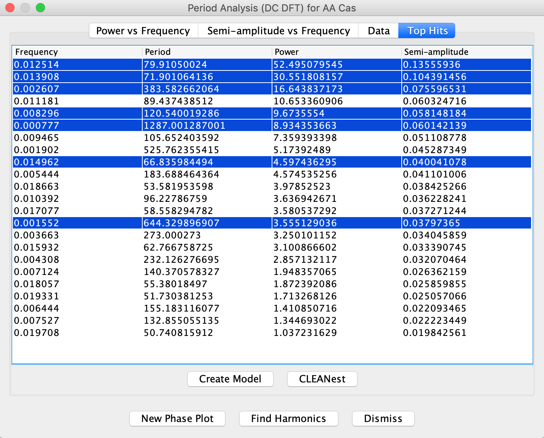
Clicking the CLEANest button from the Top Hits pane opens this dialog.

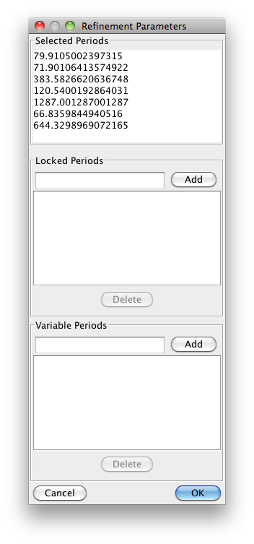
Clicking OK here adds seven new top hits with the same power value, shown multiply-selected in the top hits list and annotated on the power spectrum.
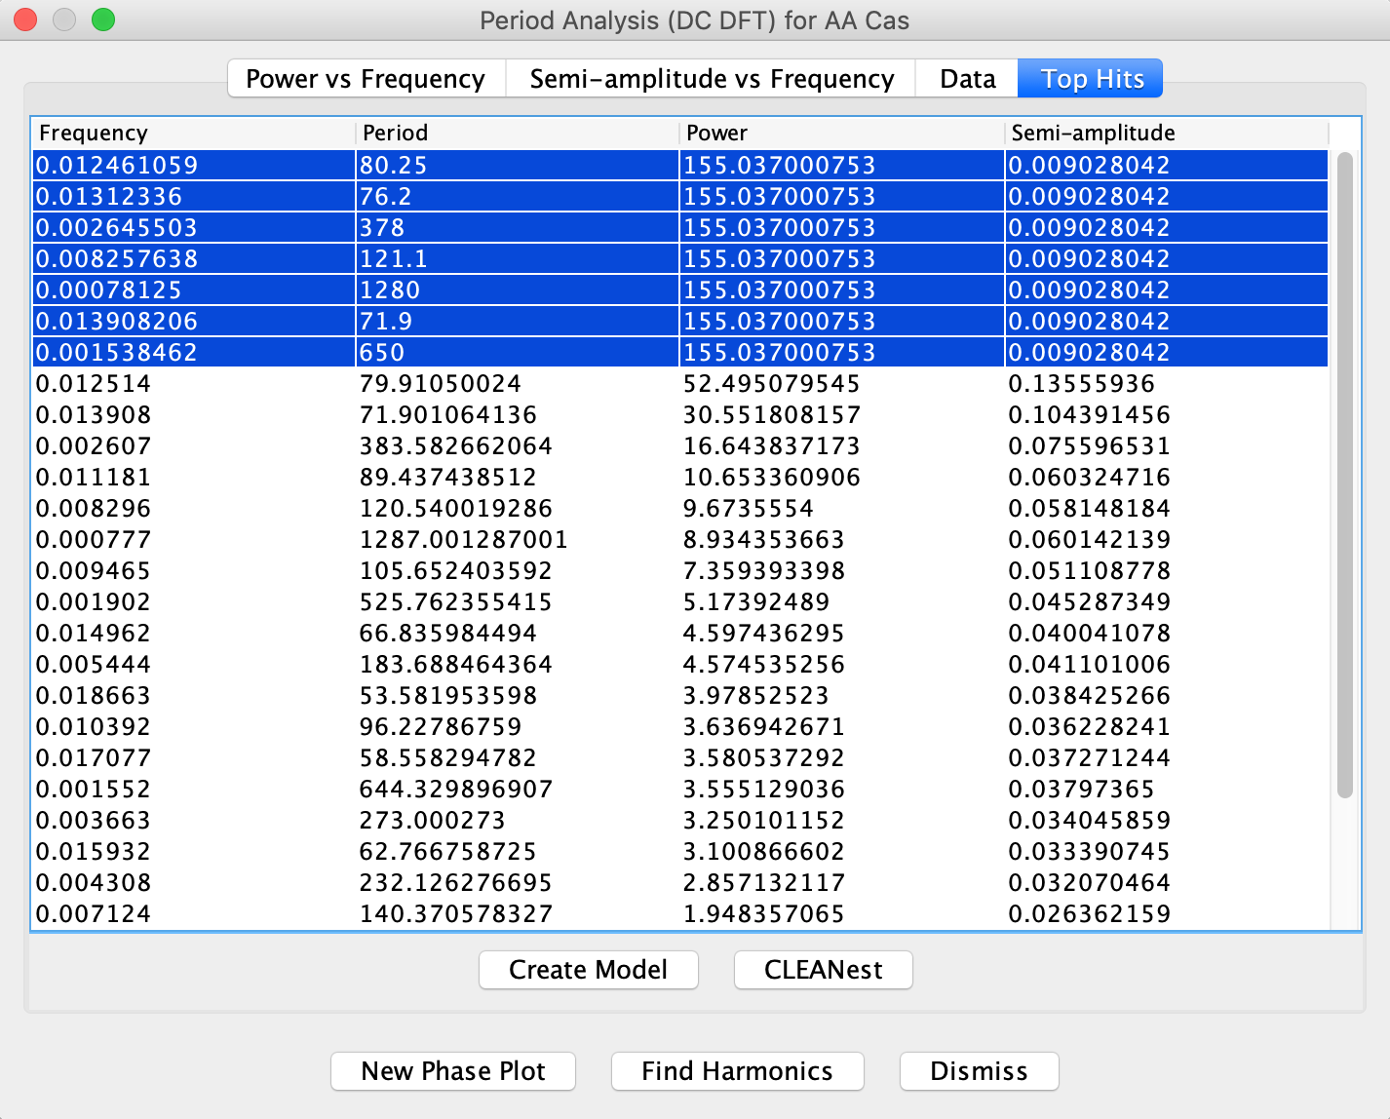
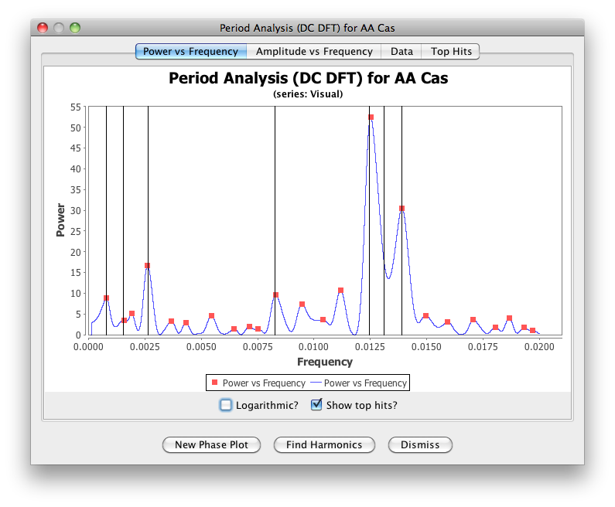

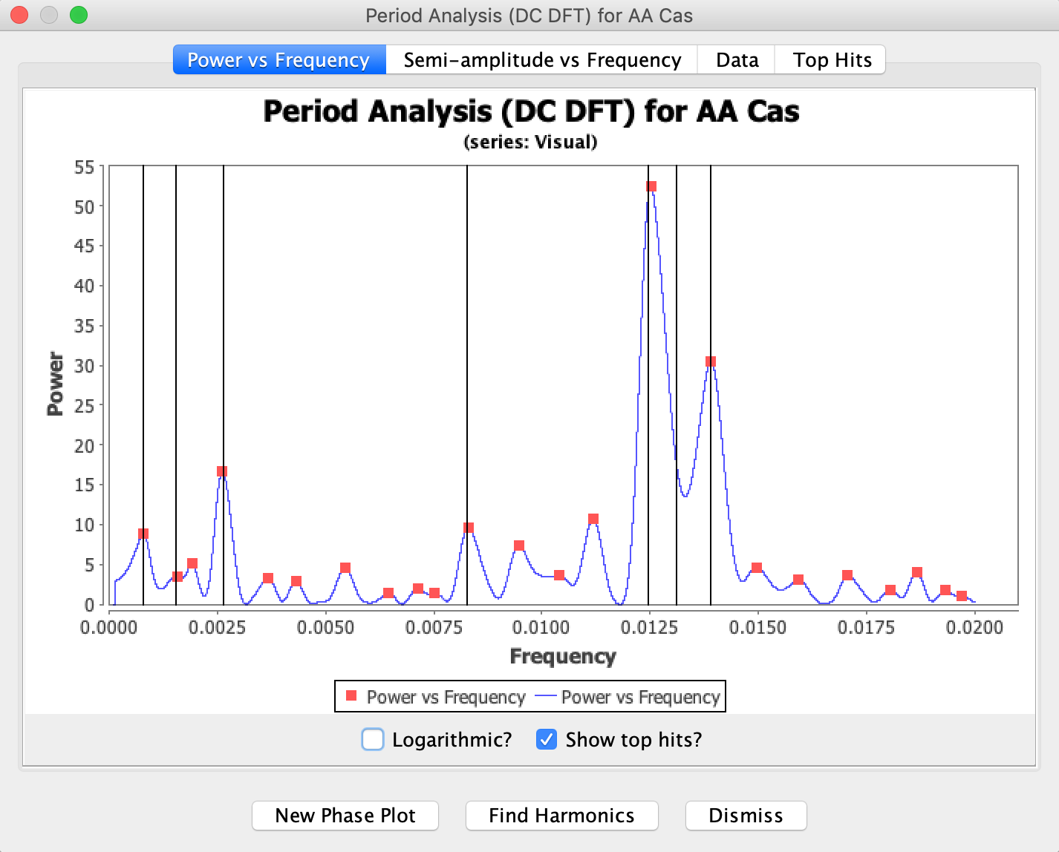
Now click Create Model in the Top Hits pane and the following dialog will open.

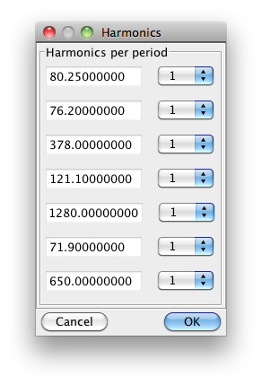
Click OK and the main plot will have an additional “model” series added. Dismiss the main DCDFT dialog to return to the main VStar window.

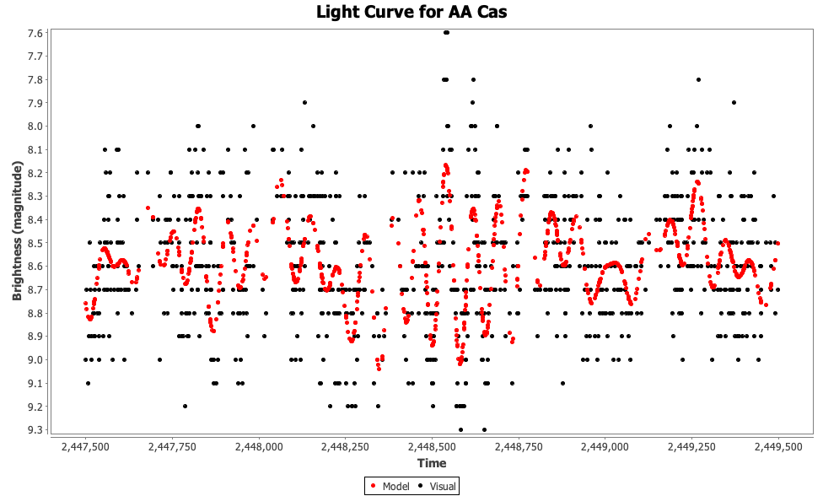

The residuals for this model can be viewed by opening the Plot Control dialog from the View menu and setting it as shown, including changing the Days per Mean Series Bin (and clicking Apply).

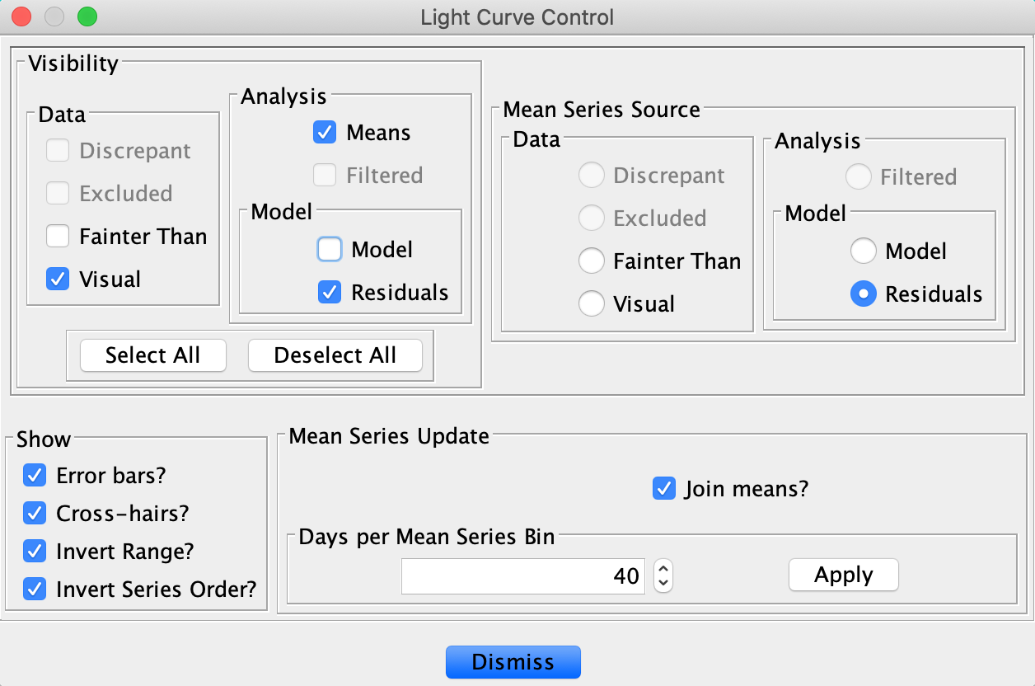
Dismissing the dialog changes the plot to look like this:

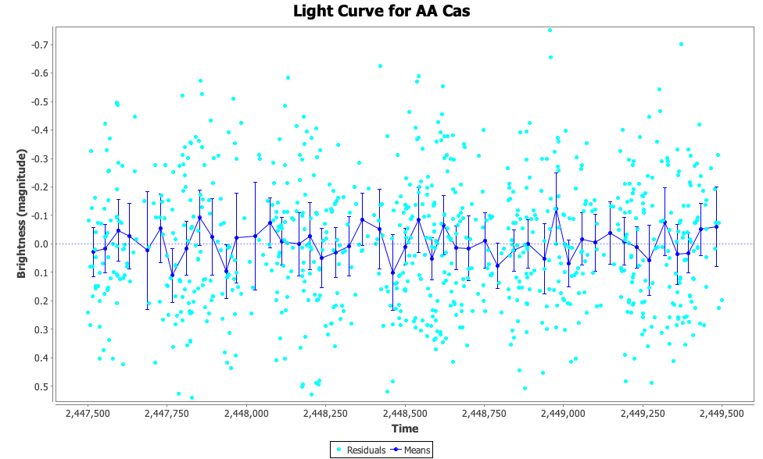

The Current Mode ANOVA plug-in could be used to show that what is observed in the residuals is likely to be due to noise rather than due to the presence of a non-trivial signal.

For another example of using CLEANest in VStar, see the following:

http://dbenn.wordpress.com/2011/07/13/bz-uma-model-and-cleanest/

